Profiles

Profiles are source records for statements and mailing lists for customer and vendors. Profiles store information about individuals and companies with whom the agency does business and are generally defined as “billing entities.”

There are four types of profiles found in Trams:
- Client (leisure/corporate)
- Vendor
- Agent
- Other

Profiles can be added into Trams by manually creating them, or they can be captured through interface from the GDS, imported by file or if the agency uses ClientBase, profiles generated through the software, will be shared with Trams.

Creating a Client Profile

- Go to Profiles | Client | Leisure or Corporate
- Under the general Tab fill in all fields that are necessary to identify the client. You should also fill in fields that you would want to view on a report.
***GDS Users: Name and Interface ID fields are required***
- There is a Primary Agent field to add agents who are exclusive to that profile only
- Communication tab: allows you to add phone numbers, fax numbers, websites and email addresses
- Travelers tab: you can link family members and employees to this account
- Payment Info tab: here you can save credit card and bank account numbers (they will be encrypted)
- Groups tab: used to classify profiles under a specific group(s) name and for reporting purposes
- Marketing tab: used for additional info about the client
- Agents tab: designed for profiles that will have more than one agent linked to it
- Attachment tab: designed to attach electronic documents to the profiles
- Once all the necessary field are filled out, click OK at the bottom
- Continue Entering Profiles: this box is auto-checked to enable the user to continue creating more profiles without opening a new screen every time. Once done with creating profiles, uncheck the box then click OK to exit.

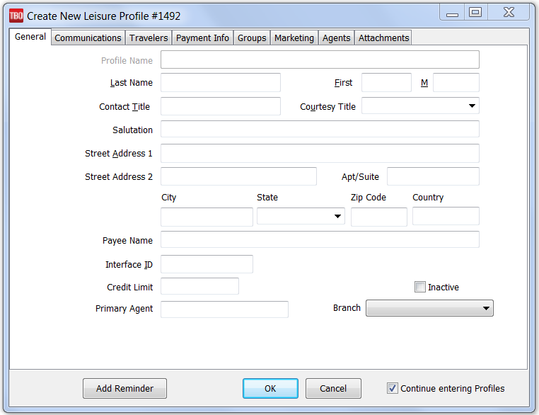

Creating a Vendor Profile

- Go to Profiles | Vendor
- Under the general Tab fill in all fields that are necessary to identify the vendor. You should also fill in fields that you would want to view on a report
***GDS Users: Name and Interface ID fields are required***
- There is a Commissions field for vendors who have a specific commissions percentage that they pay out
- Communication tab: allows you to add phone numbers, fax numbers, websites and email addresses
- Contacts tab: designed to link all contact persons to this account
- Payment Info tab: this is for vendors who pay commissions by credit card. The number can be left on file (will be encrypted)
- Groups tab: used to classify profiles under a specific group(s) name and for reporting purposes
- Marketing tab: used for additional info about the vendor
- Attachment tab: designed to attach electronic documents to the profiles
- Once all the necessary field are filled out, click OK at the bottom
- Continue Entering Profiles: this box is auto-checked to enable the user to continue creating more profiles without opening a new screen every time. Once done with creating profiles, uncheck the box then click OK to exit

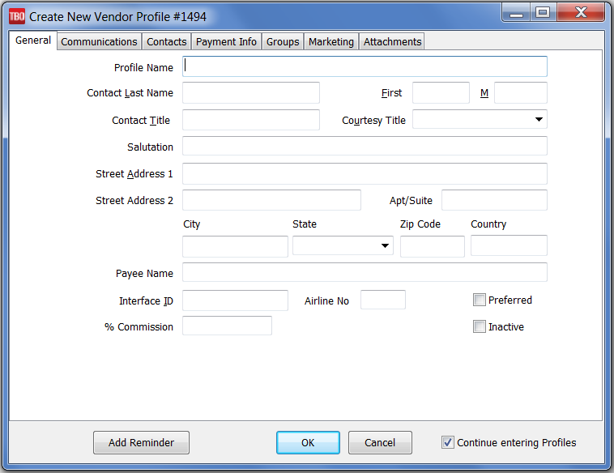

Creating an Agent Profile

- Go to Profiles | Agent
- Under the general Tab fill in all fields that are necessary to identify the agent. The profile name can be the agent’s ID but make sure you fill-in the Contact Last Name and First Name to identify the agent. You should also fill in fields that you would want to view on a report
***GDS Users: Name and Interface ID fields are required***
- Inside Rate and Outside Rate: field for general commissions. If the agent gets paid commissions on specific travel types, click on the Default Rates Tab at the top of the screen
- G/L Acct fields: the agency can designate g/l accounts to be linked whenever there’s a payment under that agent’s name
- Communication tab: allows you to add phone numbers, fax numbers, websites and email addresses
- Contacts tab: you can link family members and friends to this account
- Payment Info tab: here you can save credit card and bank account numbers (they will be encrypted)
- Groups tab: used to classify profiles under a specific group(s) name and for reporting purposes
- Marketing tab: used for additional info about the agent
- Default Rates tab: designed to allow the agency to specify commissions per travel type. You can enter a percentage rate or the dollar amount
- Attachments tab: designed to attach electronic documents to the profiles including payroll info
- Once all the necessary field are filled out, click OK at the bottom
- Continue Entering Profiles: this box is auto-checked to enable the user to continue creating more profiles without opening a new screen every time. Once done with creating profiles, uncheck the box then click OK to exit.
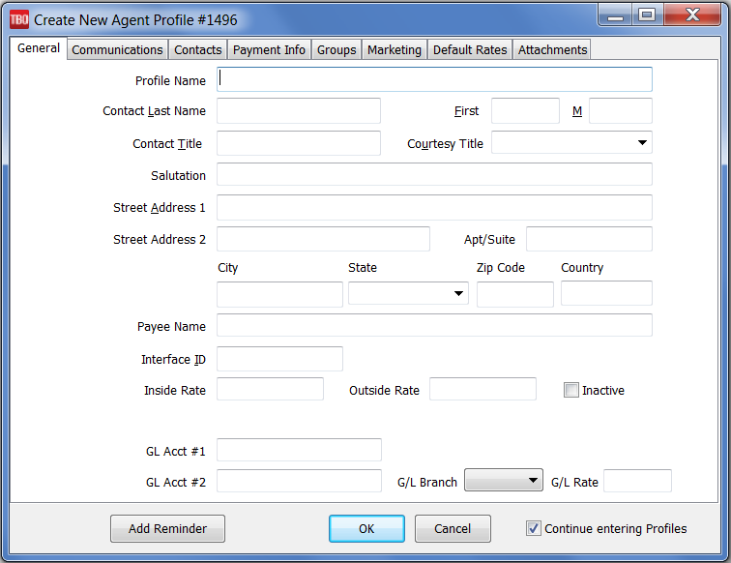
Creating an Other Profile

- Go to Profiles | Other
- Under the general Tab fill in all fields that are necessary to identify the “Other” profile (rent, bank, expenses). You should also fill in fields that you would want to view on a report
- G/L Acct fields: the agency can designate g/l accounts to be linked whenever there’s a payment under Other
- Communication tab: allows you to add phone numbers, fax numbers, websites and email addresses
- Contacts tab: designated contact person(s) to this account
- Payment Info tab: here you can save credit card and bank account numbers (they will be encrypted)
- Groups tab: used to classify profiles under a specific group(s) name and for reporting purposes
- Marketing tab: used for additional info about the agent
- Attachments tab: designed to attach electronic documents to the profiles
- Once all the necessary field are filled out, click OK at the bottom
- Continue Entering Profiles: this box is auto-checked to enable the user to continue creating more profiles without opening a new screen every time. Once done with creating profiles, uncheck the box then click OK to exit.

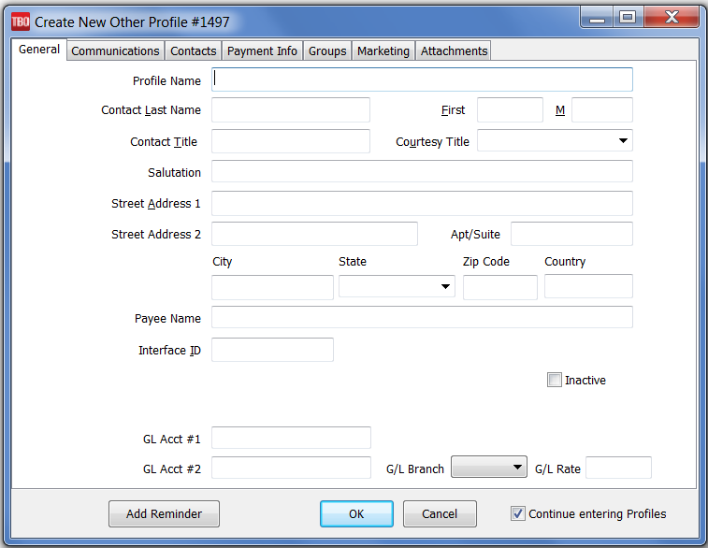

Invoices

Invoices are the daily records of sales and refunds, and are the main source of information for the system. Sales, Refund, Vouchers and Adjustment invoices are entered, queried, retrieved, modified and voided in the Invoice section of Trams Back Office. Invoices are entered into Trams Back Office either through the interface process, by entering them into ClientBase, or by manual entry. If the agency interfaces, an interface record is created each time an agent drives a ticket or an invoice.

Specific accounting, client, vendor and booking information from the interface record is downloaded to Trams Back Office and becomes available for accounting, tracking and reporting needs. Once the downloaded invoices have been received and processed by Trams Back Office, modifications can be made manually to all of the fields except the Record Number which is computer assigned.
Important Note: Trams accepts an invoice number range of 0 to 2147483647. Anything higher will NOT be accepted either manually or via the Interface.
Invoices in Trams Back Office are made up of three parts: The General Invoice Information, the Individual Booking Details, and the Booking Summary Screen. General invoice information includes information pertaining to the entire invoice, such as Invoice Number, Client Name, and Issue Date. Booking Details contain specific details of a booking, such as Airline or Vendor, Ticket or Confirmation Number, Fares and Commissions. The Booking Summary screen includes a list of all bookings entered along with Invoice Totals.
When manually building an invoice in Trams Back Office, first enter the general invoice information, then enter each booking.
Creating a Basic Sales / Refund Invoice
- Go to Invoice | Sales or Refund
- Invoice number: add the number into the field. If grayed-out that means it’s been set-up in the global defaults. Trams will add the number at the completion of building the invoice
- Date: defaults on the day of creation. It can backdated in an open period only
- Group: if applicable, add the group name
- ARC No: click on the drop-down arrow and choose the number
- Rec Loc: you can add the number
- Invoice Remarks: add any necessary remarks
- Client Name: last name first

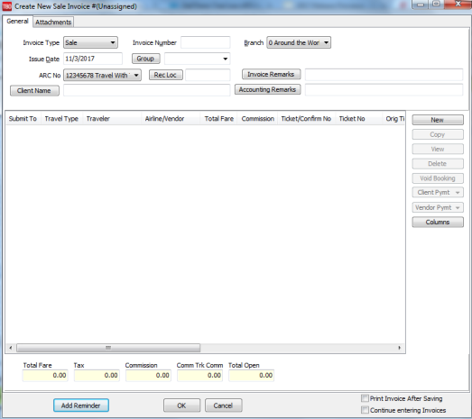
Once the fields have been filled out, click on the “NEW” button over to the right side of the screen
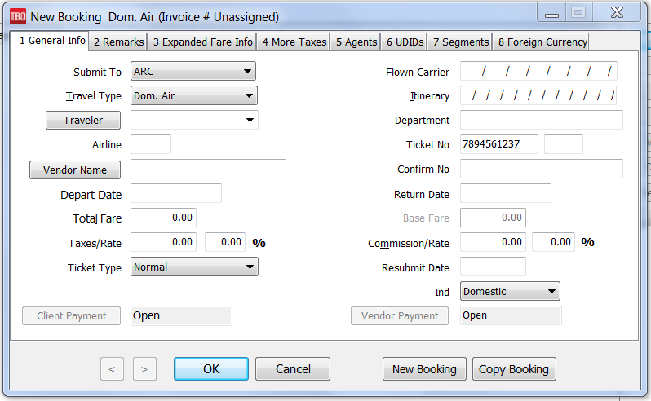
Creating a Booking/Reservation
- Submit To: ARC or Supplier or CommTrak
- Travel Type: Click on the drop-down arrow to choose
- Traveler: defaults to the client’s name. If different, type the name into the box. If the travelers have been added into the client’s profile then click on the drop-down and choose the name
- Airline: the two-letter code is needed if the Submit To is ARC
- Vendor Name: type in the first three letters of the name and click on the drop-down button
- Depart and Return Dates
- Total Fare: includes the taxes
- Base Fare: Trams will calculate the fare once the taxes and total fare have been added
- Ticket Type: if ARC, the ticket type is usually Normal unless there’s been an exchange
- Flown Carrier and Itinerary: the codes can be manually added or click on tab 7 Segments. Add each leg of the Itinerary
- Department: if applicable, agency decides on the name or codes of the department
- Ticket number: if using ARC add the 10-digit number only
- Confirmation Number: if applicable
- Commission/Rate: add the amount or the percentage rate
- Once the fields have been filled out then go to the top and click only on the tabs that are needed for that reservation. When finished, click on OK.
- Your first booking/reservation is completed. If you need to create another within the same invoice, click on the “NEW” button and repeat the process
- Once all of the bookings/reservations have been added click OK to complete the invoice
- Trams will prompt you to add a payment to the invoice. You can accept or decline. If you accept, the Payment window will open for you to add a payment. If you decline, trams will take you back to the Invoice/Query Screen

