Payments Made

Payments Made with a Profile Type of Client, Vendor or ARC/BSP are connected to an invoice. Payments Made with a Profile Type of Other and Agent are not linked to an invoice and prompts for a journal entry.
There are five profile types for payments received and payments made - Client, Vendor, Agent, Other, and ARC/BSP.
Creating a Basic Payment | Made
- Click on Payment | Made
- Fill in amount being Issued Out | date | remarks
- Choose the correct bank account and branch
- Payment method
- Profile type (who is the agency paying, vendor, agent, other)
- Fill in the name
- Click on Query
- Toggle Closed only what pertains to the amount of the payment
- When finished, the unapplied total should be at 0.00
- Click OK
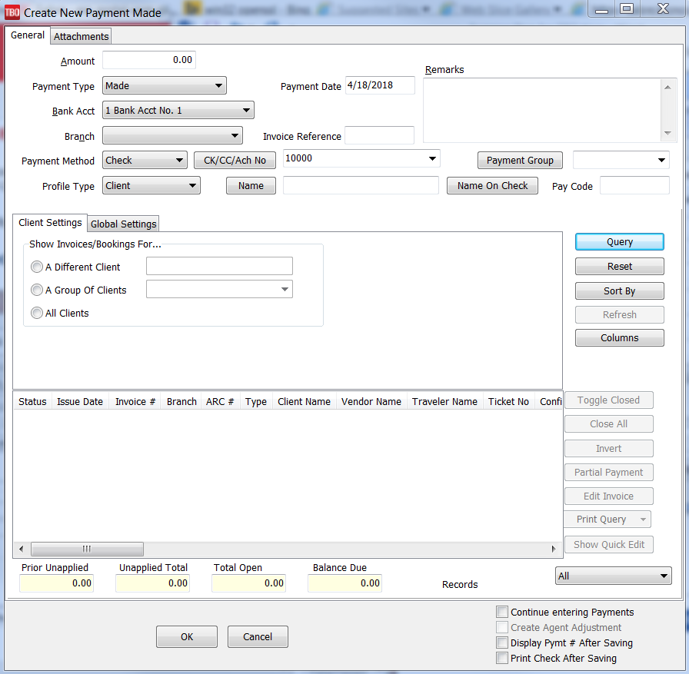
Withdrawals
Payment Withdrawal is the process of removing money from the bank account.

To enter a Withdrawal, select Payments > Withdrawal
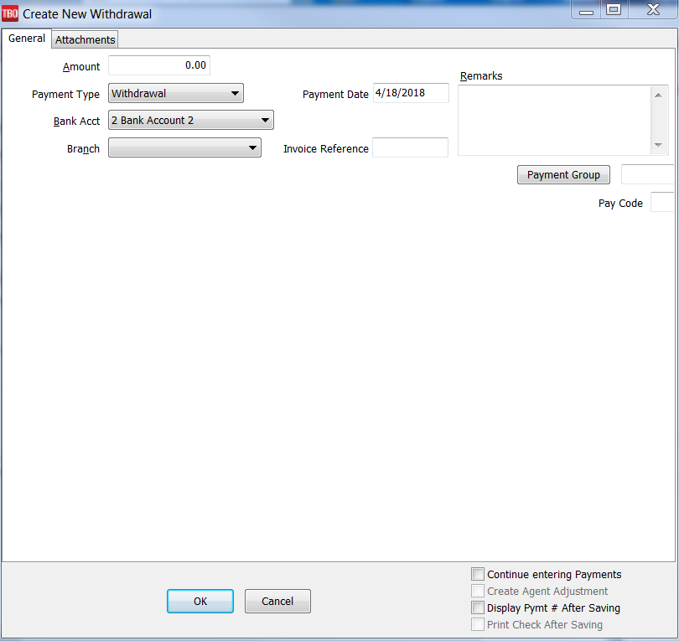
- Fill in the amount if the Withdrawal
- Date | Remarks
- Choose the correct bank and branch
- Click OK
- You will receive a prompt to create a journal entry. If you are using the general ledger, click YES
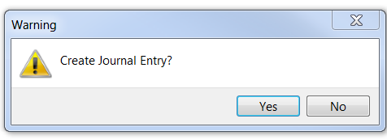
- Make your journal entry
- Confirm that the Debits / Credits match at the bottom
- Click OK

