Payments Received

Payments Received with a Profile Type of Client, Vendor or ARC/BSP are connected to an invoice. Payments Received with a Profile Type of Other and Agent are not linked to an invoice and prompts for a journal entry.
There are five profile types for payments received - Client, Vendor, Agent, Other, and ARC/BSP.
Creating a Basic Payment | Received
- Click on Payment | Received
- Fill in amount being received | date | remarks
- Choose the correct bank account and branch
- Payment method
- Profile type (who’s paying the client, vendor, agent, other)
- Fill in the name
- Click on Query
- Toggle Closed only what pertains to the amount of the payment
- When finished, the unapplied total should be at 0.00
- Click OK

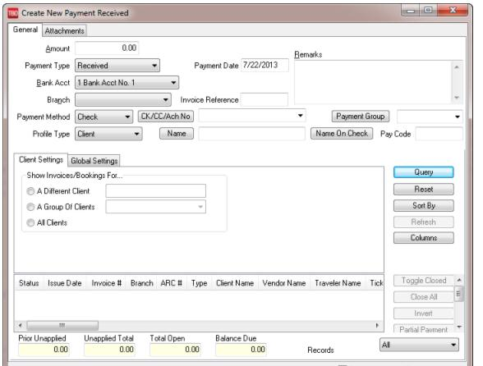
Deposits
Deposits should always represent the sum of cash and check Payments Received entered for that period. A receipts report for the day for the specific bank account should match the actual deposit amount (it is always a good idea to run a tape of the checks and make sure it matches what was entered into TBO). Trams Back Office suggests printing the receipts report and attaching it to the deposit slip.
Entering the total amount of the deposit in Trams, updates the Check Register Core Report. Entering each individual receipt that makes up the deposit updates the general ledger cash in bank accounts during an End of Period.
To enter a new deposit, select Payments | Deposit
- Fill in the amount if the deposit
- Date | Remarks
- Choose the correct bank and branch
- Fill in the Receipt Dates to include in the deposit
- Click Query
- Notice Trams has included all item as a part of the deposit
- The total Receipts and Included Receipts should match to the penny
- Over to the right, click on Print Deposit Slip
- Click OK to complete the deposit in Trams

